Community Mobility Report

The [Community Mobility Reports](https://www.google.com/covid19/mobility/?hl=en) show movement trends by region, across different categories of places. For each category in a region, reports show the changes in 2 different ways:

* Headline number: Compares mobility for the report date to the baseline day. Calculated for the report date (unless there are gaps) and reported as a positive or negative percentage.
* Trend graph: The percent changes in the 6 weeks before the report date. Shown as a graph.

[Overview - Community Mobility Reports Help (google.com)](https://support.google.com/covid19-mobility/answer/9824897?hl=en&ref_topic=9822927)

This diagram shows a report dated Mar 27 2020. The headline number (-15% to -63% in this example) is the percent change for the *latest day*—also called the [report date](https://support.google.com/covid19-mobility/answer/9824897?hl=en&ref_topic=9822927#report-date).

The headline number isn't an average or the trend of the previous changes. Notice how only the last day of the graph changes when the headline number changes.

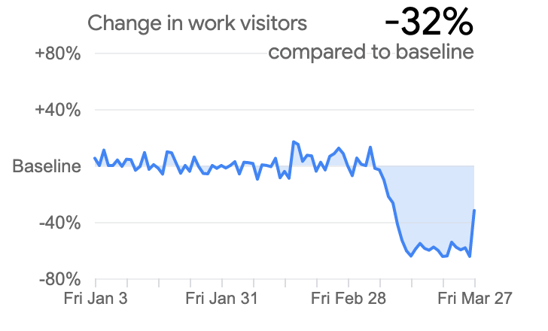

Report date

This is the date we compare in the headline numbers.

find the report date at the top of the PDF or in the filename

## Baseline

The data shows how visitors to (or time spent in) categorized places change compared to our **baseline days.**

A baseline day represents a *normal* value for that day of the week.

**median value from the 5‑week period** Jan 3 – Feb 6, 2020.

For each region-category, the baseline isn’t a single value—it’s 7 individual values.

The same number of visitors on 2 different days of the week, result in different percentage changes. So, we recommend the following:

**NOTE**

Don’t infer that larger changes mean more visitors or smaller changes mean less visitors.

Avoid comparing day-to-day changes. Especially weekends with weekdays.

## Place categories

Use categories to group some of the places with similar characteristics for purposes of social distancing guidance.

For example, we combine grocery and pharmacy as these tend to be considered essential trips.

# Calibrate your region

### How do park visitors change from January to now?

Both day-to-day and seasonal weather affects visitors to parks:

* In typical years, is there any difference in how often people visit parks between January and today?

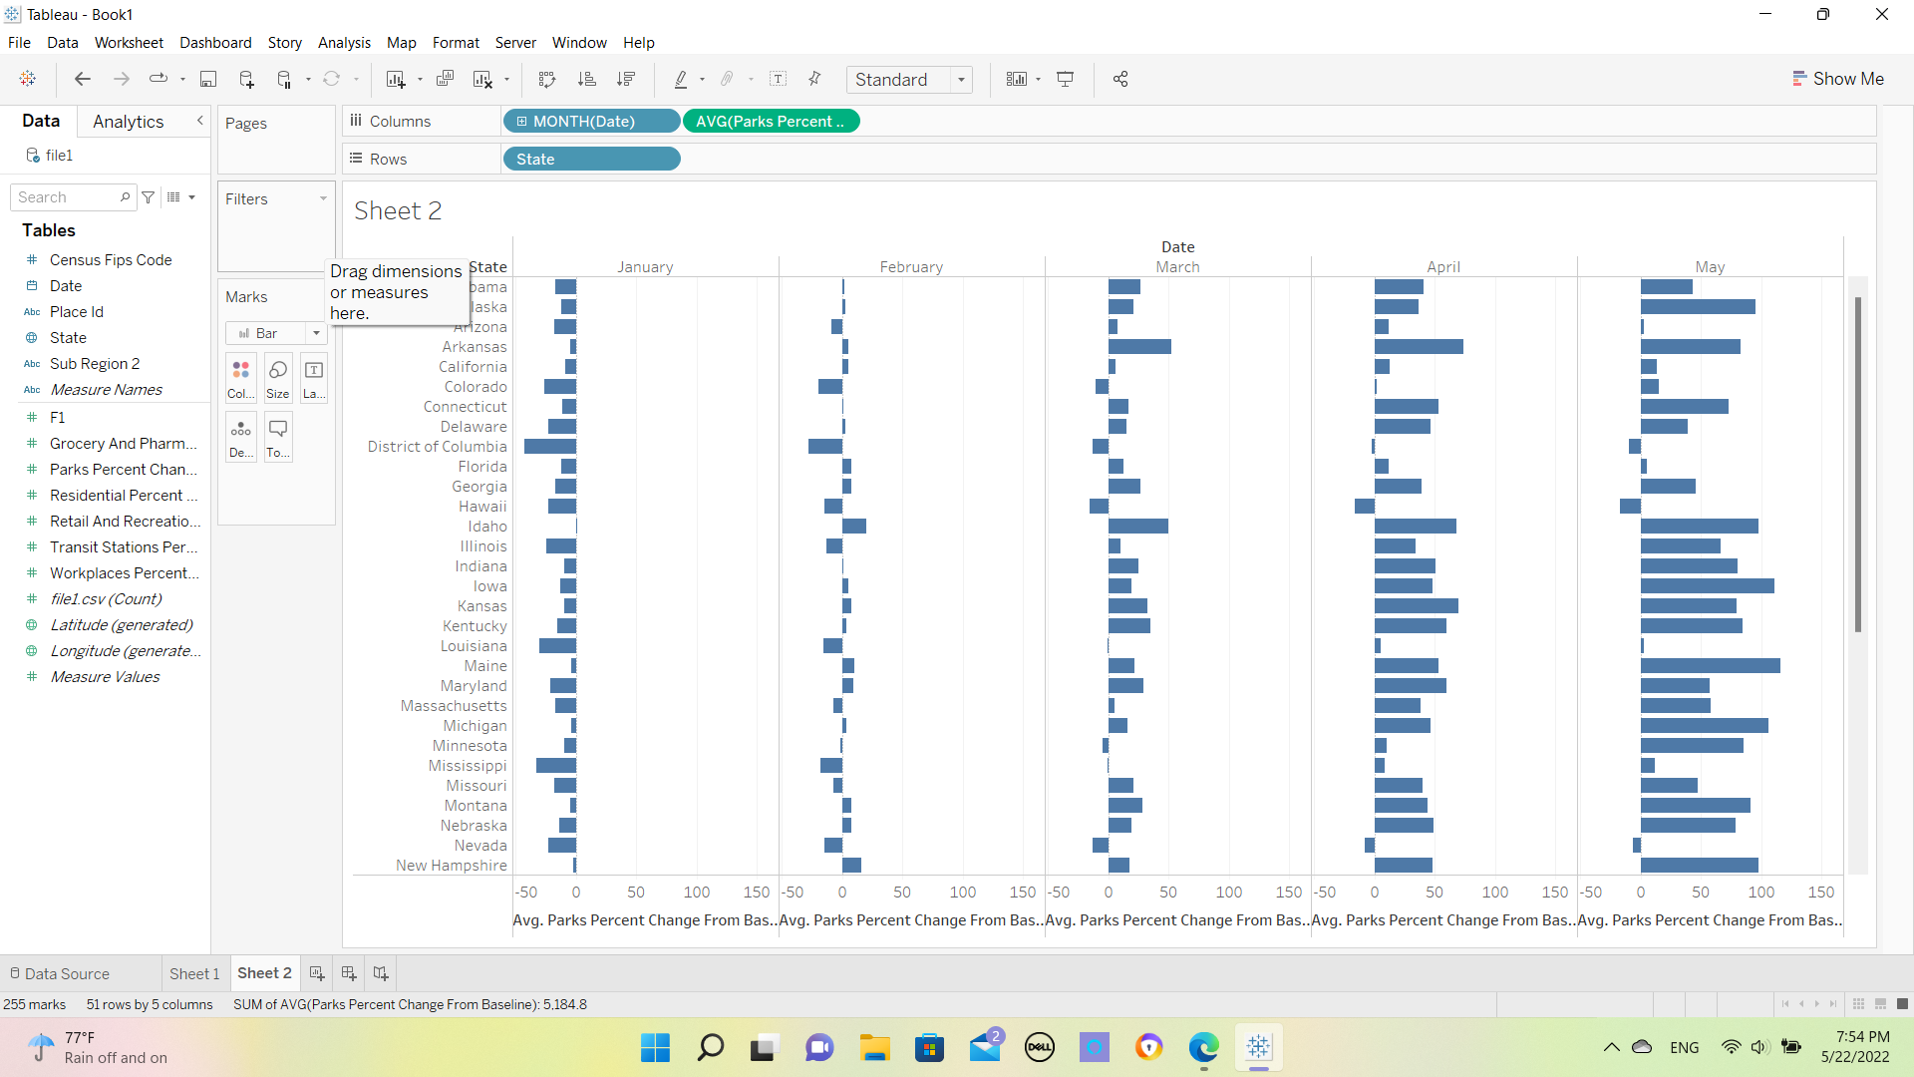

* Using weather records, how do park visitors change on rainy days compared to sunny days?
* Do you have park records from previous years that can help you calibrate the changes from this year?

### How much more time do you think people will spend in residential places?

Estimate the number of hours you think people used to spend in residential places before any responses to COVID-19. Estimate weekdays and weekends separately:

* How might the hours change for different jobs? For example, an office worker, a stay-at-home parent, a student, a grocery-store worker, or a nurse who works shifts? Use your region's demographic data to understand the range of jobs.
* For each group in your community, estimate how many hours of the day you expect them to stay in residential places while responding to COVID-19.
* Do you need to adjust your estimates based on the season or academic terms?

### How might types of work affect the mobility changes on weekdays or weekends?

We don’t report any changes for types of work, but you can think about the different jobs people in your community do on weekends and the jobs on weekdays.

* How might COVID-19 responses affect different jobs?
* Would the effects be different for weekday workers than weekend workers?

